Project Design Phase-II
Data Flow Diagram & User Stories

Date | 30 September 2026
Team ID | SWTID-2026-2617
Project Name | Streamlining IT Procurement: Automating Standard Laptop Orders with Flow Designer
Team Size | 4
Team Leader | Goushikram G
Team Members | Santhosh Karthick A  Jason Selvin Raj J  Abutharick M
Maximum Marks | 4 Marks

Data Flow Diagrams:
A Data Flow Diagram (DFD) is a traditional visual representation of the information flows within a system. A neat and clear DFD can depict the right amount of the system requirement graphically. It shows how data enters and leaves the system, what changes the information, and where data is stored.
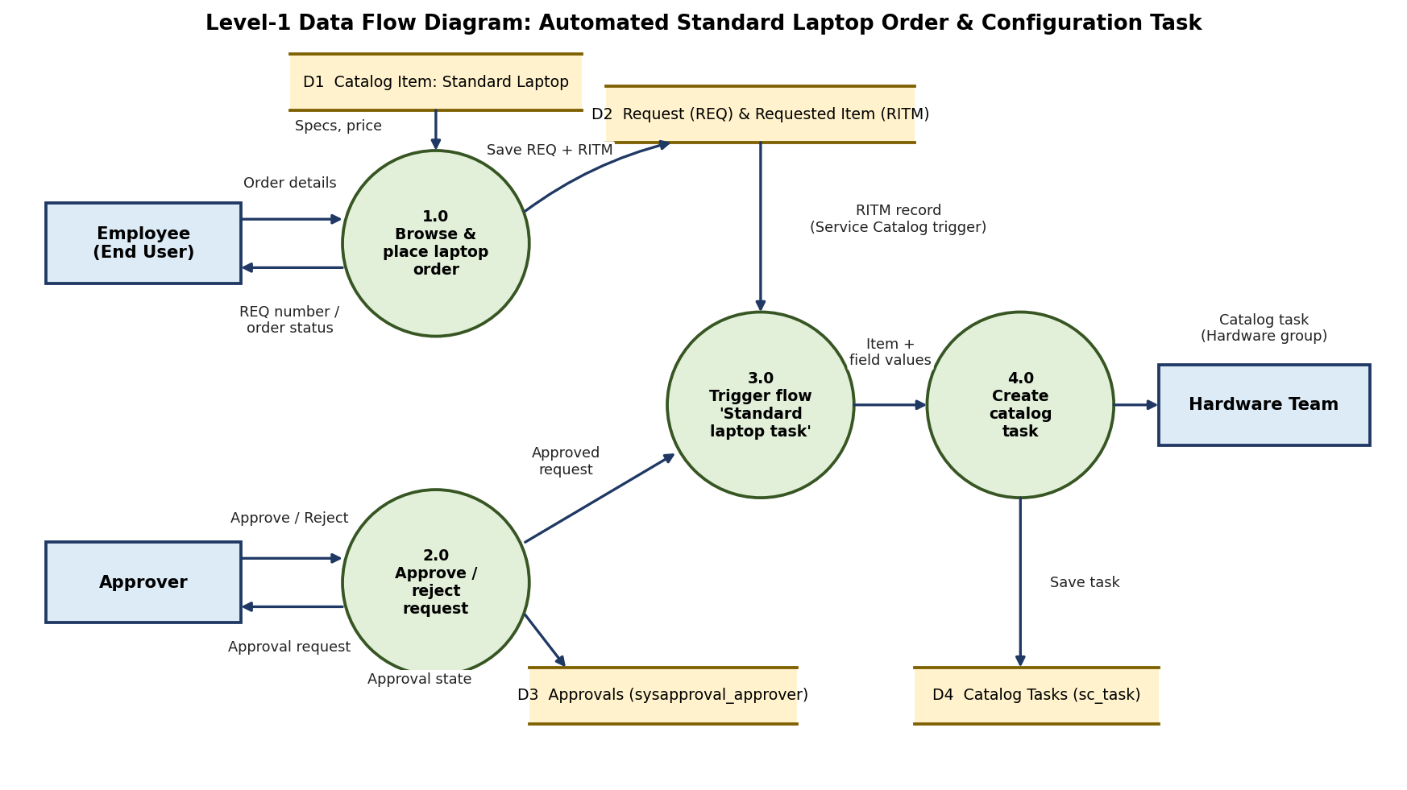
1. The employee selects the Standard Laptop item in the Service Catalog (Hardware) and places the order; the Request (REQ) and Requested Item (RITM) are saved.
2. An approval request is sent to the approver, who approves or rejects it from the Approvers section.
3. The Service Catalog trigger starts the flow "Standard laptop task" for the Requested Item.
4. The Create Catalog Task action creates the task with short description "Laptop needs to Configured", Assignment group Hardware and Approval Approved.
5. The catalog task is saved and appears for the Hardware team (and under Catalog Tasks on the RITM) for configuration.

User Stories
Use the below template to list all the user stories for the product.
User Type | Functional Requirement (Epic) | User Story Number | User Story / Task | Acceptance criteria | Priority | Release
End User (Employee) | Service Catalog Ordering | USN-1 | As an employee, I can browse Service Catalog > Hardware and open the Standard Laptop item to see its specifications and price. | I can see the Lenovo Carbon x1 details, optional software and the Order Now button | High | Sprint-1
 |  | USN-2 | As an employee, I can place an order for a Standard Laptop using Order Now. | I get the message that my request has been submitted with a Request Number (REQ) | High | Sprint-1
 | Request Tracking | USN-3 | As an employee, I can open my request and requested item to track its status. | I can see the Requested Item and its Catalog Tasks | Medium | Sprint-2
Approver | Request Approval | USN-4 | As an approver, I can open the Approvers section of the request and approve it. | The approval state changes from Requested to Approved | High | Sprint-2
 |  | USN-5 | As an approver, I can reject a request that should not be fulfilled. | The approval state changes to Rejected | Medium | Sprint-2
IT Procurement Team Member | Flow Automation | USN-6 | As a member of the IT procurement team, I want a flow with a Service Catalog trigger so that standard laptop orders start the process automatically. | The flow "Standard laptop task" is saved and Active | High | Sprint-1
 | Catalog Task Creation | USN-7 | As a member of the IT procurement team, I want a catalog task created automatically after the order is approved so that no manual intervention is needed. | A catalog task with short description "Laptop needs to Configured" is created for the Requested Item | High | Sprint-2
Hardware Team Member | Laptop Configuration | USN-8 | As a hardware team member, I can see the catalog task assigned to the Hardware group so that I can configure the laptop promptly when it arrives. | The task shows the short description and the Hardware assignment group | High | Sprint-2
Administrator | Flow Assignment | USN-9 | As an administrator, I can attach the flow to the Standard Laptop catalog item using the Process Engine. | The Standard Laptop item shows the flow "Standard laptop task" in the Process Engine tab | High | Sprint-1
 | Flow Configuration | USN-10 | As an administrator, I can run the flow as System User in the Global application so that tasks are always created. | The flow runs without user permission errors | Medium | Sprint-3

